**UNIVERSITY OF AGRICULTURE FAISALABAD**

**DEPARTMENT OF COMPUTER SCIENCE**



**Degree BS Software Engineering**

**Semester 6th**

**Course Title Mobile App Development**

**Course Code SE – 512**

**Project Name: Unique Cars**

**Presented By: Aima Arif**

**Present To: Dr.Kareem Ullah**

**Frontned:**

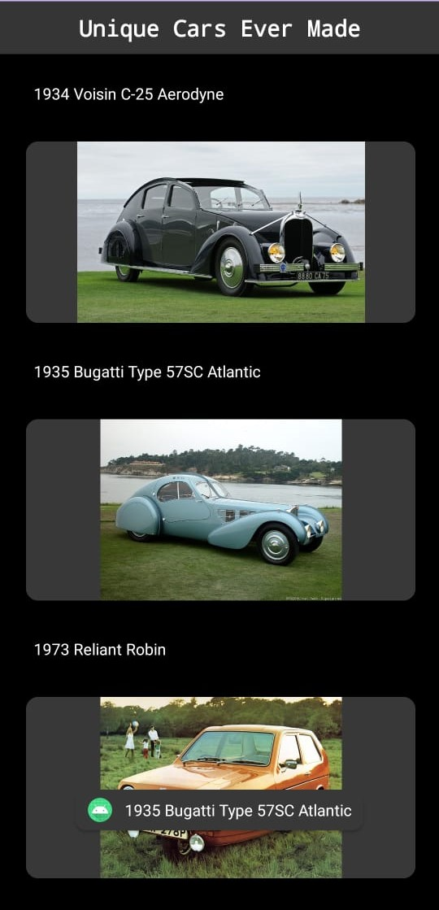

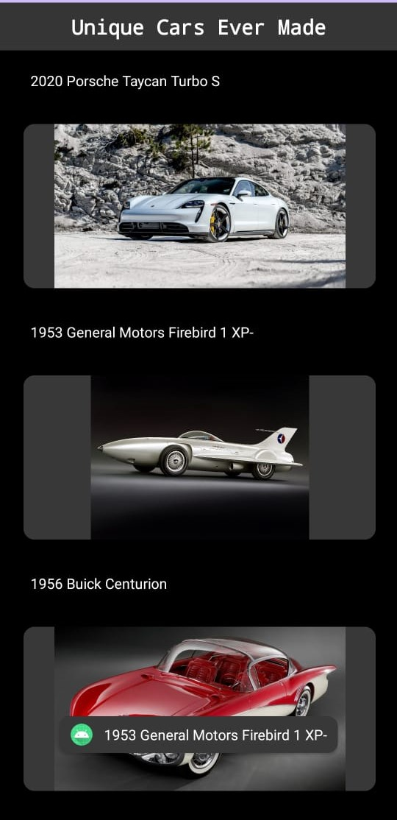

**MainActivity.java File:**

package com.example.cardviewapp;  
  
import androidx.appcompat.app.AppCompatActivity;  
import androidx.cardview.widget.CardView;  
import androidx.recyclerview.widget.LinearLayoutManager;  
import androidx.recyclerview.widget.RecyclerView;  
  
import android.os.Bundle;  
import android.view.View;  
import android.widget.AdapterView;  
import android.widget.Toast;  
  
import com.example.cardviewapp.Adapters.CarAdapter;  
import com.example.cardviewapp.Models.CarModel;  
  
import java.util.ArrayList;  
  
public class MainActivity extends AppCompatActivity implements SelectListener{  
  
 RecyclerView recyclerView;  
  
  
 @Override  
 protected void onCreate(Bundle savedInstanceState) {  
 super.onCreate(savedInstanceState);  
 setContentView(R.layout.*activity_main*);  
 recyclerView=findViewById(R.id.*reView*);  
  
 ArrayList<CarModel> arrlist = new ArrayList<>();  
 arrlist.add(new CarModel(R.drawable.*bertone* , "1970 Lancia Bertone Stratos HF Zero"));  
 arrlist.add(new CarModel(R.drawable.*electriq* , "1942 L’oeuf Electrique"));  
 arrlist.add(new CarModel(R.drawable.*timbs* , "1948 Norman Timbs Special"));  
 arrlist.add(new CarModel(R.drawable.*lancia* , "2021 Tesla Roadster"));  
 arrlist.add(new CarModel(R.drawable.*gmd*, "2021 GMD T.50"));  
 arrlist.add(new CarModel(R.drawable.*delorean*, "1981 DeLorean DMC-12"));  
 arrlist.add(new CarModel(R.drawable.*tesla*, "2020 Porsche Taycan Turbo S"));  
 arrlist.add(new CarModel(R.drawable.*motor*, "1953 General Motors Firebird 1 XP-"));  
 arrlist.add(new CarModel(R.drawable.*loeuf*, "1956 Buick Centurion"));  
 arrlist.add(new CarModel(R.drawable.*voisin*, "1934 Voisin C-25 Aerodyne"));  
 arrlist.add(new CarModel(R.drawable.*norman*, "1935 Bugatti Type 57SC Atlantic"));  
 arrlist.add(new CarModel(R.drawable.*robin*, "1973 Reliant Robin"));  
 arrlist.add(new CarModel(R.drawable.*amphicar*, "1961 Amphicar Model 700"));  
 arrlist.add(new CarModel(R.drawable.*ghia*, "1955 Chrysler Ghia Streamline"));  
 arrlist.add(new CarModel(R.drawable.*bmw*, "BMW Isetta 1955"));  
  
  
  
 CarAdapter adapter = new CarAdapter(arrlist, this, this);  
 recyclerView.setAdapter((adapter));  
  
 LinearLayoutManager layoutManager = new LinearLayoutManager(this);  
 recyclerView.setLayoutManager(layoutManager);  
  
  
 }  
  
 @Override  
 public void onItemClicked(CarModel carModel) {  
 Toast.*makeText*(this, carModel.getText(), Toast.*LENGTH_SHORT*).show();  
 Toast.*makeText*(this, String.*valueOf*(carModel.getImages1()), Toast.*LENGTH_SHORT*).show();  
 }  
}

**CarAdapter.java:**

package com.example.cardviewapp.Adapters;  
  
import android.annotation.SuppressLint;  
import android.content.Context;  
import android.text.Layout;  
import android.view.LayoutInflater;  
import android.view.View;  
import android.view.ViewGroup;  
import android.widget.ArrayAdapter;  
import android.widget.ImageView;  
import android.widget.TextView;  
  
import androidx.annotation.NonNull;  
import androidx.recyclerview.widget.RecyclerView;  
  
import com.example.cardviewapp.Models.CarModel;  
import com.example.cardviewapp.R;  
import com.example.cardviewapp.SelectListener;  
import androidx.cardview.widget.CardView;  
  
import java.util.ArrayList;  
  
public class CarAdapter extends RecyclerView.Adapter<CarAdapter.viewHolder> {  
 ArrayList<CarModel> arrlist;  
 Context context;  
 private SelectListener listener;  
  
  
 public CarAdapter(ArrayList<CarModel> arrlist, Context context, SelectListener listener){  
 this.arrlist = arrlist;  
 this.context = context;  
 this.listener = listener;  
 }  
  
 @NonNull  
 @Override  
 public viewHolder onCreateViewHolder(@NonNull ViewGroup parent, int viewType) {  
 View view = LayoutInflater.*from*(context).inflate(R.layout.*sample_recyclerview*,parent,false);  
 return new viewHolder(view);  
 }  
  
 @Override  
 public void onBindViewHolder(@NonNull viewHolder holder, @SuppressLint("RecyclerView") int position) {  
 CarModel model = arrlist.get(position);  
 holder.imgview.setImageResource(model.getImages1());  
 holder.txtview.setText(model.getText());  
 holder.cardView.setOnClickListener(new View.OnClickListener() {  
 @Override  
 public void onClick(View view) {  
 listener.onItemClicked(arrlist.get(position));  
 }  
 });  
  
 }  
  
 @Override  
 public int getItemCount() {  
 return arrlist.size();  
 }  
  
 public class viewHolder extends RecyclerView.ViewHolder{  
 ImageView imgview;  
 TextView txtview;  
 CardView cardView;  
  
 public viewHolder(@NonNull View itemView){  
 super(itemView);  
 imgview = itemView.findViewById(R.id.*imageView*);  
 txtview = itemView.findViewById(R.id.*textView*);  
 cardView = itemView.findViewById(R.id.*c1*);  
 }  
  
 }  
}

**CarModel.java:**

package com.example.cardviewapp.Models;  
  
public class CarModel {  
 private int images1;  
 private String text;  
  
 public CarModel(int images1, String text) {  
 this.images1 = images1;  
 this.text = text;  
 }  
  
 public int getImages1() {  
 return images1;  
 }  
  
 public void setImages1(int images1) {  
 this.images1 = images1;  
 }  
  
 public String getText() {  
 return text;  
 }  
  
 public void setText(String text) {  
 this.text = text;  
 }  
}